CPE301 – SPRING 2020

MIDTERM 1

Student Name: Do Le

Student #: 2001183621

Student Email: [led2@unlv.nevada.edu](mailto:led2@unlv.nevada.edu)

Primary Github address: <https://github.com/DoVietLe>

Directory: <https://github.com/DoVietLe/assignments>

Q: Write, simulate, and demonstrate using Atmel Studio 7 a C code for the AVR ATMEGA328p microcontroller that performs the following functions:

1. Program the UART Module to interact with the ATmega328/p:

2. On transmitting the following keys from the host terminal, the following actions will be performed:

1. On-reboot or ‘h’ key – help screen (list all keys and functionalities)

2. ‘t’ display temperature in C of LM34/35 on terminal, ‘T’ - display temperature in F of LM34/35 on terminal.

3. ‘o’ turns ON LED at PB5, ‘O’ turns OFF the LED at PB5.

4. ‘s’ sends a string to the terminal.

5. ‘i’ sends an integer to the terminal. Use the integer as a delay in seconds to blink the LED PB2.

1. **COMPONENTS LIST AND CONNECTION BLOCK DIAGRAM w/ PINS**

Components

• Xplained Mini Board

* + ATmega328PB
  + Programmer
  + Debugger

• Arduino Multifunction Shield

• LM35 Temperature Sensor

• Atmel Studios 7.0

* + Compiler
  + Serial Monitor

Block Diagram

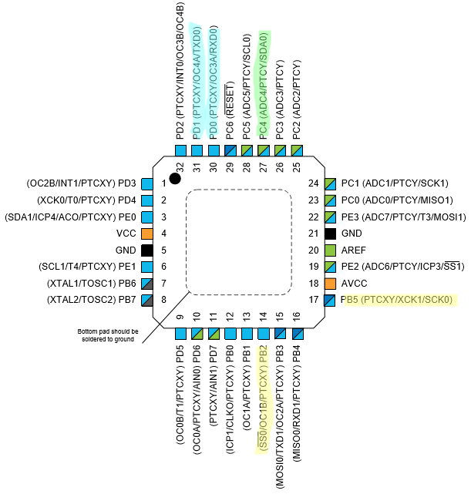

Figure : Block diagram

PD0 and PD1 used for serial communication

PB2 and PB5 used for LEDs

PC4 used for analog to digital

1. **INITIAL/MODIFIED/DEVELOPED CODE OF TASK 1/A**

Code

#include <avr/interrupt.h>

#include <avr/io.h>

#define CYCLES_1s 15624 // Amount of cycles for 1s delay @16MHz, 1024 pre-scaler.

#define UBBR_VALUE 103

// Lists the functionalities.

const char functionalities[] = "h - Help screen \n"

"t - Display temperature in centrigrade \n"

"T - Display temperature in fahrenheit \n"

"o - Turn on PB5 LED \n"

"O - Turn off PB5 LED \n"

"s - Send a string to the terminal \n"

"i - Send an integer to the terminal \n\n";

const char myString[] = "CPE 301 Midterm.\n";

// Keeps track of the delay between blinks of LED on PB2. Initialized to 1s.

volatile int delayAmount = 0;

volatile int delayMax = 1;

// Stores the temperature as a string.

volatile char temperatureString[10];

volatile char integer[10];

void enableRandomTimer() {

// Enables timer in normal mode with a pre-scaler of 1024.

TCCR0A = 0x00;

TCCR0B = 0x05;

}

*uint8_t* getInt() {

*uint8_t* num = TCNT0;

num ^= (num<<(num%8));

return num % 10;

}

void initializeBlinkingLED() {

// Sets PB2 as output.

DDRB |= (1<<2);

PORTB &= ~(1<<2);

// Set interrupt settings.

OCR1A = CYCLES_1s;

TIMSK1 = 0b00000010; // Enables interrupt on compare match A.

TIFR1 |= 0x02; // Clears the interrupt flag.

sei();

// Sets timer settings.

TCCR1B = 0b00001101; // Sets timer1 to be in CTC mode with 1024 pre-scaler.

TCCR1A = 0b00000000;

TCNT1 = 0;

}

// Enables ADC.

void enableADC() {

// Sets PINC4 as input.

DDRC &= ~(1<<4);

// Sets up ADC settings.

ADMUX = 0xC4; // Reads from ADC4. Right justified. Internal 1.1V reference.

ADCSRB = 0x00; // Free running mode.

ADCSRA = 0b10000111; // Enables ADC with 128 pre-scaler.

}

// Disables ADC.

void disableADC() {

ADCSRA &= 0x7F; // Disables the ADEN bit.

}

// Converts an analog to digital value on PC0.

*uint16_t* analogRead() {

ADCSRA |= (1<<6); // Enables ADSC to start AD conversion.

while (!(ADCSRA&(1<<4))); // Waits until ADIF is set indicating ADC is done.

ADCSRA |= (1<<4); // Clears ADIF flag.

return ADC; // Returns value.

}

// Uses a formula to convert a digital read value to temperature (formula works for 1.1V reference voltage).

float analogToTemp(*uint16_t* t, char unit) {

// Takes analog converted number and converts it into temperature.

//return t;

float convertedTemp = t*110/1023;

switch (unit) {

case 't':

return convertedTemp; // Returns temperature in Celsius.

case 'T':

default:

return convertedTemp*1.8 + 32; // Returns temperature converted to Fahrenheit.

}

}

*uint8_t* asciiToInt8(*uint8_t* n) {

if (n >= 48 && n <= 57) {

sendByte();

return n - 48;

}

return 1;

}

// Sets up UART.

void setUART() {

// Sets port.

DDRD |= 0x02;

// Sets baud rate.

UBRR0 = UBBR_VALUE;

// Sets UART settings.

UCSR0C |= 0b00000110; // to async mode with no parity

}

// Enables transmitter on PORTD1.

void enableTransmit() {

// Sets port.

DDRD |= 0x02;

UCSR0B |= 0b00001000; // Enables transmit line.

}

// Disables the transmitter on UART.

void disableTransmit() {

UCSR0B &= ~(1<<TXEN0);

}

// Enables receiver on PORTD0.

void enableReceive() {

// Sets port.

DDRD &= ~1;

UCSR0B |= (1<<RXEN0); // Enables receive line.

}

// Sends one byte of data out the TX line.

void sendByte(*uint8_t* b) {

if (UCSR0B & (1<<TXEN0)) { // Checks whether transmit is enabled.

while (!(UCSR0A & (1<<UDRE0))); // Waits until the UDR0 register is ready.

UDR0 = b; // Sends the byte.

}

}

// Sends every ASCII byte in a string.

void sendString(char string[]) {

int i = 0;

while (string[i] != '\0')

sendByte(string[i++]);

}

char getByte() {

while (!(UCSR0A & (1<<7))); // Waits until the data is fully received.

return UDR0;

}

int main(void)

{

// Sets everything up.

enableRandomTimer();

enableADC();

setUART();

enableTransmit();

enableReceive();

initializeBlinkingLED();

DDRB |= (1<<5); // Enables PB5 and PB2 for the LEDs.

PORTB &= ~(1<<5);

sendString(functionalities);

while (1) {

// Polls for a serial data on the RX line.

char instr = getByte();

// When data is sent, perform something based on the instructions

// if the instruction is defined. Otherwise, poll again.

if (instr == 'h') {

sendString(functionalities);

} else if (instr == 't' || instr == 'T') {

*uint16_t* temp = analogRead(); // Reads in temperature and converts.

float convertedTemp = analogToTemp(temp, instr);

*snprintf*(temperatureString, 10, "%f\n", convertedTemp);

sendString(temperatureString);

sendByte('\n');

} else if (instr == 'o') {

PORTB &= ~(1<<5); // Turns on LED.

} else if (instr == 'O') {

PORTB |= (1<<5); // Turns off LED.

} else if (instr == 's') {

sendString(myString);

} else if (instr == 'i') {

*uint8_t* num = getInt(); // Grabs a random integer.

*snprintf*(integer, 10, "%d\n", num);

sendString(integer); // Sends the integer to the terminal.

sendByte('\n');

delayMax = num; // Replaces delay with new integer.

}

}

}

ISR(TIMER1_COMPA_vect) {

TIFR1 |= 0x02; // Clears interrupt flag.

delayAmount = (delayAmount + 1) % delayMax;

if (delayAmount == 0)

PORTB ^= (1<<2); // Toggles PB2.

}

1. **DEVELOPED MODIFIED CODE OF TASK 2/A from TASK 1/A**

There is no modified code.

1. 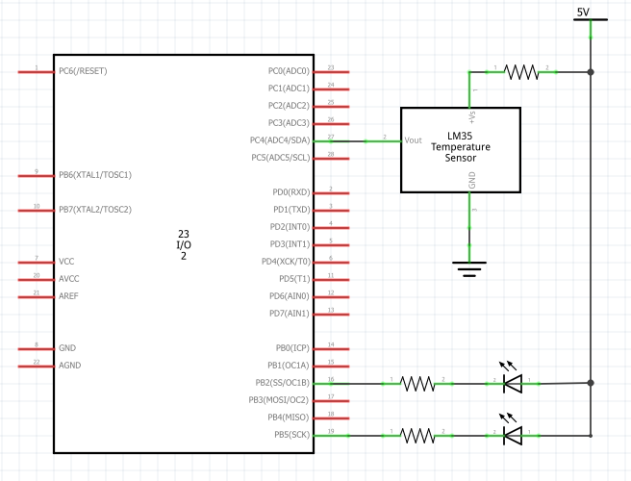**SCHEMATICS**

Figure : Schematic

1. **SCREENSHOTS OF EACH TASK OUTPUT (ATMEL STUDIO OUTPUT)**

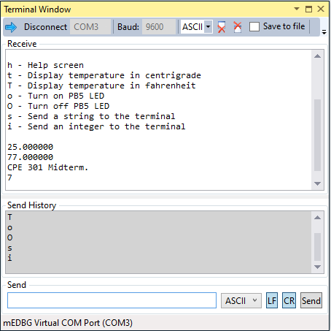

Figure : Terminal window on Atmel Studio 7.0

1. **SCREENSHOT OF EACH DEMO (BOARD SETUP)**

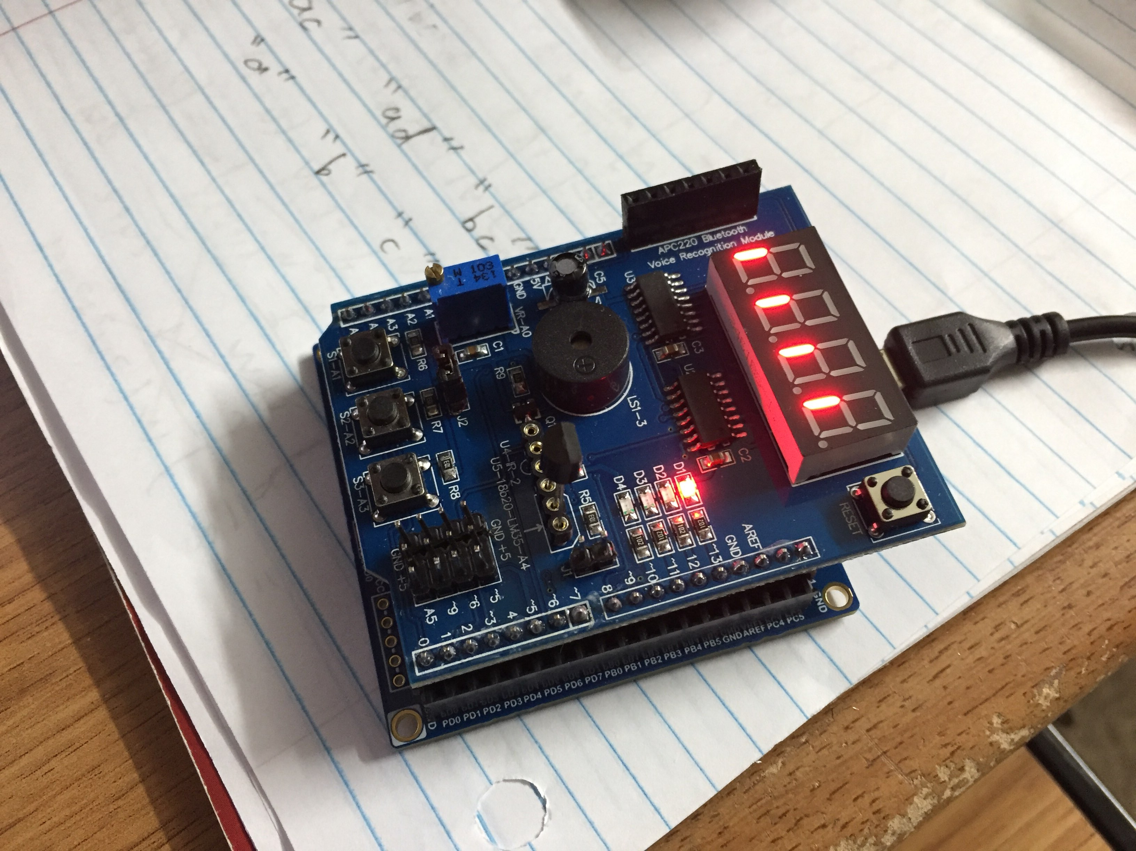

Figure : Board layout

1. **VIDEO LINKS OF EACH DEMO**

Video Link

https://www.youtube.com/watch?v=2N9_knIlBPk

1. **GITHUB LINK OF THIS DA**

https://github.com/DoVietLe/assignments/tree/master/ESD301/Midterm

**Student Academic Misconduct Policy**

<http://studentconduct.unlv.edu/misconduct/policy.html>

“This assignment submission is my own, original work”.

Do V. Le